Question 01:
(a) Probability of drawing a red card: P(Red) = 26/52 = 1/2
(b) Given that a red card is drawn, probability that it is a heart: P(Heart | Red) = 13/26 = 1/2
(c) Given that the drawn card is a face card, probability that it is a diamond: P(Diamond | Face Card) = 3/12 = 1/4
(d) Given that the card drawn is a face card, probability that it is a spade or a queen: P(Spade or Queen | Face Card) = (3 + 4 - 1)/12 = 6/12 = 1/2

Question 02:

Network structure:
Intelligence → Grade, StudyHours → Grade, Difficulty → Grade, Grade → Pass

Network:
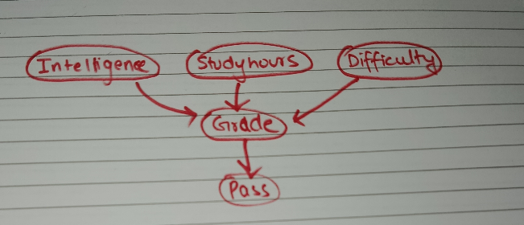

Prior probabilities:
Node | State | Probability
Intelligence | High / Low | 0.7 / 0.3
StudyHours | Sufficient / Insufficient | 0.6 / 0.4
Difficulty | Hard / Easy | 0.4 / 0.6

Conditional Probability Table for Grade
Intelligence | StudyHours | Difficulty | P(A) | P(B) | P(C)
High | Sufficient | Easy | 0.70 | 0.20 | 0.10
High | Sufficient | Hard | 0.50 | 0.30 | 0.20
High | Insufficient | Easy | 0.40 | 0.35 | 0.25
High | Insufficient | Hard | 0.25 | 0.35 | 0.40
Low | Sufficient | Easy | 0.35 | 0.40 | 0.25
Low | Sufficient | Hard | 0.20 | 0.35 | 0.45
Low | Insufficient | Easy | 0.15 | 0.35 | 0.50
Low | Insufficient | Hard | 0.05 | 0.25 | 0.70

Conditional Probability Table for Pass
Grade | P(Pass = Yes) | P(Pass = No)
A | 0.95 | 0.05
B | 0.80 | 0.20
C | 0.50 | 0.50

Inference results
• P(Pass = Yes | StudyHours = Sufficient, Difficulty = Hard) = 0.779
• P(Intelligence = High | Pass = Yes) = 0.730

Question 03:
Network structure:
Disease influences Fever, Cough, Fatigue, and Chills.

Network:
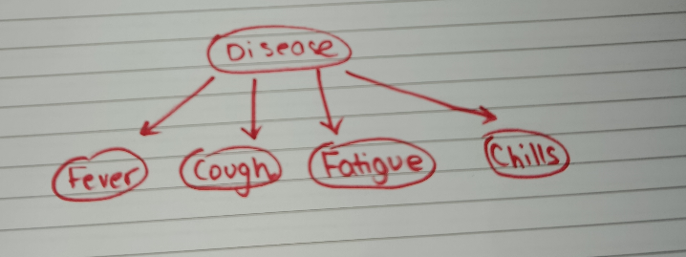

Prior probability for Disease
Disease | Probability
Flu | 0.3
Cold | 0.7
Fever | Disease
Disease | P(Fever=Yes) | P(Fever=No)
Flu | 0.9 | 0.1
Cold | 0.5 | 0.5
Cough | Disease
Disease | P(Cough=Yes) | P(Cough=No)
Flu | 0.8 | 0.2
Cold | 0.6 | 0.4
Fatigue | Disease
Disease | P(Fatigue=Yes) | P(Fatigue=No)
Flu | 0.7 | 0.3
Cold | 0.3 | 0.7
Chills | Disease
Disease | P(Chills=Yes) | P(Chills=No)
Flu | 0.6 | 0.4
Cold | 0.4 | 0.6

Inference results
• P(Flu | Fever = Yes, Cough = Yes) = 0.507
• P(Cold | Fever = Yes, Cough = Yes) = 0.493
• P(Flu | Fever = Yes, Cough = Yes, Chills = Yes) = 0.607
• P(Cold | Fever = Yes, Cough = Yes, Chills = Yes) = 0.393
• P(Fatigue = Yes | Disease = Flu) = 0.70

Question 04:
States: Sunny, Cloudy, Rainy
Transition matrix
Current State | Sunny | Cloudy | Rainy
Sunny | 0.6 | 0.3 | 0.1
Cloudy | 0.3 | 0.4 | 0.3
Rainy | 0.2 | 0.3 | 0.5
Simulation setup:
Start with Sunny and simulate weather for the next 10 days.
Required result:
Probability of having at least 3 rainy days over the 10-day period is approximately 0.35.

